**Tutorial 8 – PHP – part 1**

Repo link: https://github.com/tinkerness/S7_Web_Programming/tree/main/tutorials/tut8

Hosted link: <https://tinkerness.github.io/S7_Web_Programming/tutorials/tut8/index.html>

1. **Design an HTML form for entering a number by the user. Write a PHP code to display a message indicating, whether the number is odd or even, when clicking on the submit button.**

<!DOCTYPE html>

<html lang="en">

<head>

    <meta charset="UTF-8">

    <meta name="viewport" content="width=device-width, initial-scale=1.0">

    <title>Odd or Even</title>

</head>

<body>

    <h1>Odd or Even Number Checker</h1>

    <form method="post" action="odd_even.php">

        Enter a number: <input type="text" name="num" />

        <input type="submit" value="Check" />

        <br/><br/>

    </form>

    <?php

    if ($_SERVER["REQUEST_METHOD"] == "POST") {

        if (isset($_POST["num"])) {

            $number = $_POST["num"];

            if (is_numeric($number)) {

                if ($number % 2 == 0) {

                    echo "The number $number is even.";

                } else {

                    echo "The number $number is odd.";

                }

            }

            else {

                echo "Please enter a valid number.";

            }

        }

    }

    ?>

</body>

</html>

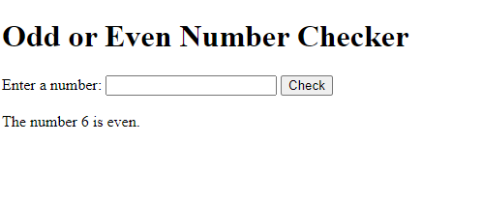

1. **Write a PHP script to count the instances of words in a string?**

<!DOCTYPE html>

<html lang="en">

<head>

    <meta charset="UTF-8">

    <meta name="viewport" content="width=device-width, initial-scale=1.0">

    <title>Words Count</title>

</head>

<body>

    <h1>Words Count</h1>

    <?php

    $text = "Round the decay

    Of that colossal Wreck, boundless and bare

    The lone and level sands stretch far away.";

    function countWords($text) {

        echo "Input Text : " . $text . "<br/><br/>";

        // Remove punctuation and convert to lowercase

        $text = strtolower(preg_replace("/[[:punct:]]/", "", $text));

        // Split into array of words

        $words = preg_split('/\s+/', $text, -1, PREG_SPLIT_NO_EMPTY);

        $wordCount = array();

        foreach ($words as $word) {

            if (isset($wordCount[$word])) {

                $wordCount[$word]++;

            } else {

                $wordCount[$word] = 1;

            }

        }

        return $wordCount;

    }

    $wordCount = countWords($text);

    echo "<b>Word counts in the text:</b><br>";

    foreach ($wordCount as $word => $count) {

        echo "$word: $count<br>";

    }

    ?>

</body>

</html>

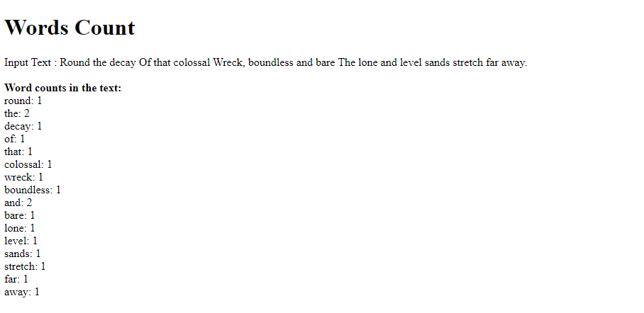

1. **What is server side scripting? Write a PHP program to check whether the given number is Armstrong or not?**

**Server side scripting**: - It refers to the execution of scripts on a web server rather than on the user's device (client-side). It involves writing code in server-side scripting languages, such as PHP, Python, Ruby, or Node.js, to generate dynamic web content, process data, interact with databases, and perform various server-side tasks. Server-side scripts are executed on the web server, and the resulting HTML, XML, or other content is sent to the client's web browser for rendering.

**Armstrong Number**: - also known as a narcissistic number, it is a number that is equal to the sum of its own digits raised to the power of the number of digits.

For example, 153 🡪 1^3 + 5^3 + 3^3 = 1 + 125 + 27 = 153

<!DOCTYPE html>

<html lang="en">

<head>

    <meta charset="UTF-8">

    <meta name="viewport" content="width=device-width, initial-scale=1.0">

    <title>Armstrong</title>

</head>

<body>

    <h1>Armstrong Number Checker</h1>

    <form method="post" action="armstrong.php">

        Enter a number: <input type="text" name="num" />

        <input type="submit" value="Check" />

        <br/><br/>

    </form>

    <?php

*function isArmstrong($number) {*

*$numStr = (string)$number;*

*$sum = 0;*

*// sum of each digit raised to the power of the number of digits*

*$numDigits = strlen($numStr);*

*for ($i = 0; $i < $numDigits; $i++) {*

*$digit = (int)$numStr[$i];*

*$sum += pow($digit, $numDigits);*

*}*

*// Check if the sum is equal to the original number*

*if ($sum == $number) {*

*return true;*

*} else {*

*return false;*

*}*

*}*

    if ($_SERVER["REQUEST_METHOD"] == "POST") {

        if (isset($_POST["num"])) {

            $numberToCheck = $_POST["num"];

            if (is_numeric($numberToCheck)) {

                if (isArmstrong($numberToCheck)) {

                    echo "$numberToCheck is an Armstrong number.";

                } else {

                    echo "$numberToCheck is not an Armstrong number.";

                }

            }

            else {

                echo "Please enter a valid number.";

            }

        }

    }

    ?>

</body>

</html>

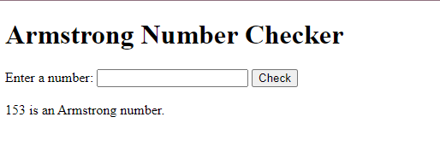

1. **Write a PHP script to search for a particular string pattern in a text.**

<!DOCTYPE html>

<html lang="en">

<head>

    <meta charset="UTF-8">

    <meta name="viewport" content="width=device-width, initial-scale=1.0">

    <title>String Pattern</title>

</head>

<body>

    <h1>String Pattern</h1>

    <form action="str_pattern.php" method="post">

        Enter string: <input type="text" name="str1" id="str1"/>

        <br/><br/>

        Enter pattern: <input type="text" name="pat1" id="pat1"/>

        <br/><br/>

        <input type="submit" name="submit" value="Check" />

    </form>

    <br/><br/>

    <?php

    if ($_SERVER["REQUEST_METHOD"] == "POST") {

        if(isset($_POST['str1']) && isset($_POST['pat1']))

        {

            $string = $_POST['str1'];

            $inputpattern = $_POST['pat1'];

            $pattern = "/" . preg_quote($inputpattern, '/') . "/i";

            if (preg_match($pattern,$string)) {

                echo "The string pattern \"$pattern\" is found in \"$string\".";

            }

            else {

                echo "The string pattern \"$pattern\" is not found in \"$string\".";

            }

        }

    }

    ?>

</body>

</html>

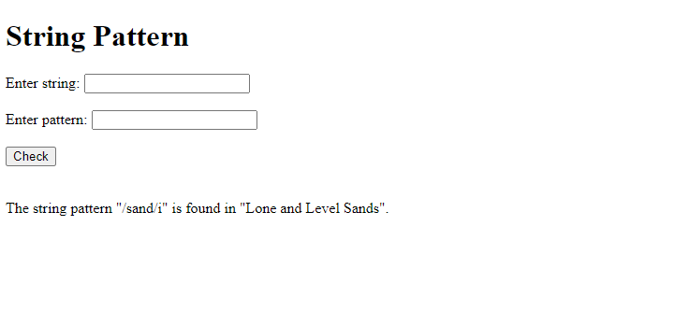

1. **Write a PHP program to sort the set of student names in ascending order..**

<!DOCTYPE html>

<html lang="en">

<head>

<meta charset="UTF-8">

<meta name="viewport" content="width=device-width, initial-scale=1.0">

<title>Sorting Student Names</title>

</head>

<body>

<h1>Sorting Student Names</h1>

<?php

$studentNames = array("Alice", "David", "Charlie", "Bob", "Eve");

echo "<b>Before Sorting:</b><br>";

foreach ($studentNames as $name) {

echo $name . "<br>";

}

echo "<br/>";

sort($studentNames);

echo "<b>After Sorting:</b><br>";

foreach ($studentNames as $name) {

echo $name . "<br>";

}

?>

</body>

</html>

